Zoom Quick Guide

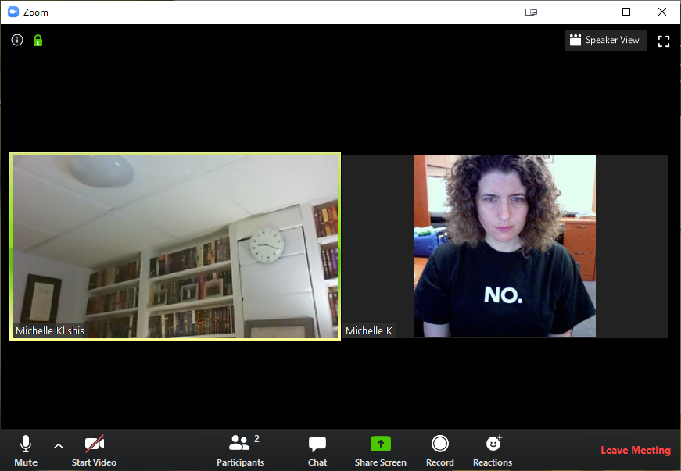
When you join a class, you generally do not need your camera on, and it is polite to mute your microphone when the instructor is speaking, except if you have a question.
The options you definitely want to be aware of are:

Mute / Unmute
Start / Stop Video
Chat
Live Transcript
Speaker / Gallery View
Leave

- Make sure your microphone is on Mute until the instructor asks for questions.
- Keep your video OFF unless and until the instructor prompts you.
- Please change your name to reflect who is attending.
- Use Live Transcript to toggle subtitles on and off (if available).
- Use the Chat function to ask questions and converse with your fellow students.
- You can exit the class or meeting at any point in time with the Leave / Leave Meeting option.
- If you are attending a session where one person is speaking, you will want Speaker View.
- If you are socializing, you will want Gallery View.
By default, the controls will disappear when you are not using them. Tap the screen or move the mouse over the Zoom window to make them reappear.

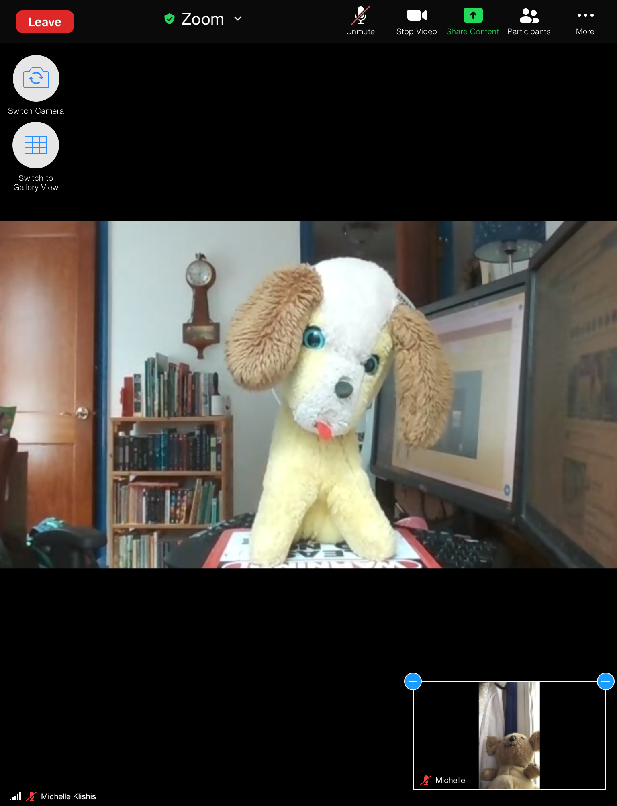
On a smart phone, and depending upon whether you are using an apple or an android device, your options may be slightly different.
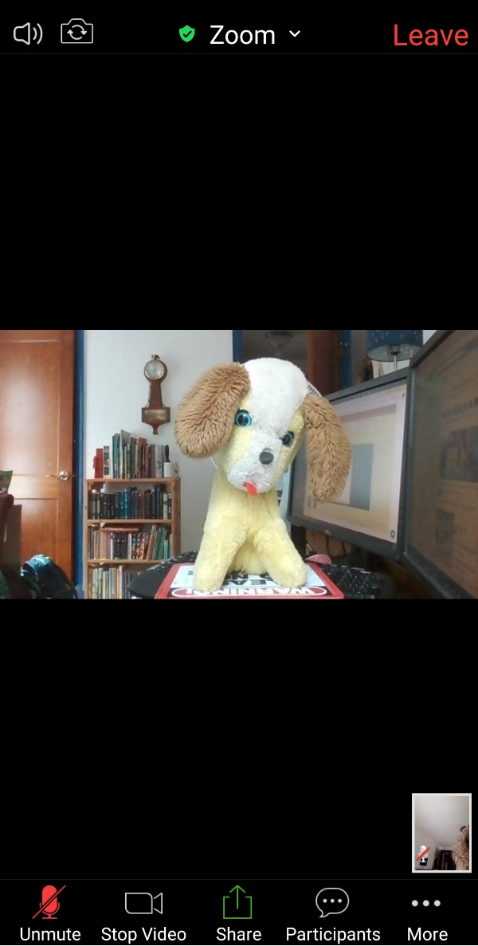

For more information, please check out our Document Repository (https://olliatwvu.org/current-members/document-repository) and our blog resources (https://olliatwvu.wpcomstaging.com/any-sufficiently-advanced-technology/online-resources/attending-an-olli-wvu-zoom-class)

