Using Microsoft Word
Table of Contents
The Word Screen 2
Document View Buttons 2
Selecting Text 3
Using the Arrow Keys 3
Using the Mouse 3
Line Spacing 4
Paragraph Alignment 4
Show/Hide Codes 4
Page Layout 5
Page Breaks 5
Bullets and Numbering 5
Indents 6
First Line Indent 6
Left and Right Indents 6
Hanging Indents 6
Tabs 7
Styles 7
Find / Replace 8

Spell Check........................................................ 9
Pictures ............................................................. 9
Formatting Pictures.......................................... 9
Tables.............................................................. 10
Table Rows...................................................... 10
Table Columns ................................................ 10
Row Height and Column Width ..................... 12
AutoFit ............................................................ 12
Sort...................................................................12
Columns ...........................................................13
Column Breaks ................................................13
Envelopes.........................................................14
Return Address Labels ....................................14
Updating Date and Time .................................15
Page Numbering ..............................................15
Default Settings ...............................................16
How-To Table of Contents ..............................17
Word Quick Reference ................................... 18

Updated: 15 February 2019
As with most computer software programs, there are usually multiple ways to do the same thing. No one way is “right”, there is just the way you remember or find easiest. Don’t let anyone tell you that you are doing something “wrong” if it works and you can remember it.

The Word Screen

Quick Access Toolbar Title Bar
Ribbon Options

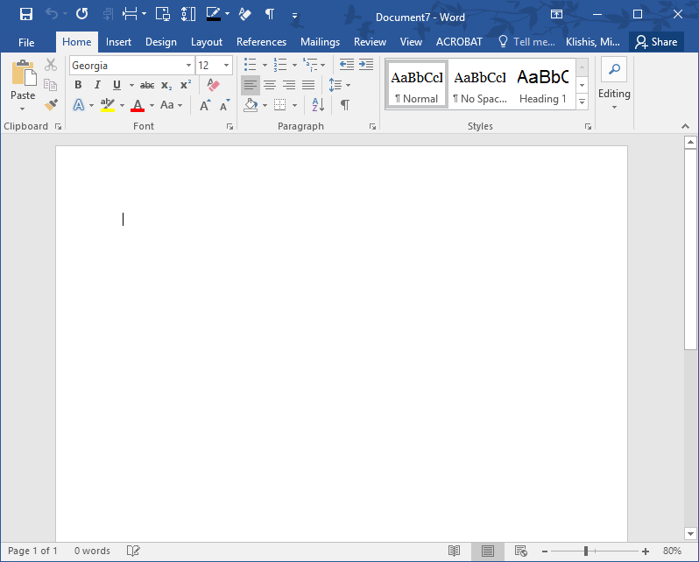Ribbon
Scroll Bar

Status
Bar

Document
Views Zoom

Document View Buttons
The StatusBar contains buttons that allow you to switch between the different document views. These view options are also accessible from the View tab of the ribbon.

The document view buttons are Read Mode, Print Layout, and Web Layout. You will probably spend most of your time in Print layout view.

Selecting Text
You will often need to select chunks of text to change their formatting or location. There are multiple ways to select text.
Using the Arrow Keys

Selecting Characters
- Place the cursor at the beginning of the text to be selected.
- Press and hold the Shift key.
- Press the right or left arrow key to highlight text one character at a time.
- Press the up or down arrow key to select one line of text at a time.

Selecting Whole Words
1. Use the keyboard command Ctrl + Shift + left/right arrow.

Selecting Whole Paragraphs
1. Use the keyboard command Ctrl + Shift + up/arrow.
Using the Mouse

Selecting a Whole Word
1. Double click in the word to be selected.

Selecting a Sentence
1. Hold the Ctrl key and click in the sentence to be selected.

Selecting a Line
- 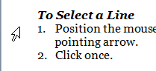Position the mouse in the left margin beside the line to be selected. The cursor changes to a right pointing arrow.
- Click once.

Selecting a Paragraph
- Position the mouse in the left margin beside the paragraph to be selected. The cursor changes to a right pointing arrow.
- Double click.

Selecting the Entire Document
1. Select the Home tab. At the far right of the ribbon, in the Editing section, choose Select and then Select All.
OR
Use the keyboard command Ctrl + A.

Deselecting Text
1. Press one of the arrow keys.
OR
Click the left mouse button outside of the selected area.

Line Spacing
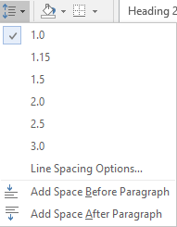Line spacing is the distance between lines in your document. Most formal documents use single line spacing. School papers and drafts of articles often use double line spacing, so comments can be written between the lines.

Changing Line Spacing
- Select the text to be modified. If the line spacing for the entire document is to be changed, select the entire document.
- In the Paragraph section of the Home tab, click the Line Spacing button, then select the desired line spacing. If the option you want is not available, select Line Spacing Options.

Paragraph Alignment
Alignment reflects how the paragraphs are laid out on the page and how they fit along the margins.

Changing Paragraph Alignment
- 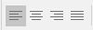Select the text to be modified. If the alignment of the whole document is to be changed, select the entire document.
- In the Paragraph section of the Home tab, select one of the Alignment buttons:
Left, Center, Right, or Justify.

Show/Hide Codes
The Show/Hide Codes button toggles whether formatting marks are visible on the screen. These marks represent spaces, tabs, hard returns, and other formatting.
These codes are turned off and on with the Show/Hide Codes button on the Home tab of the ribbon.

Page Layout
Document layout and formatting commands are available from the Page Layout tab.

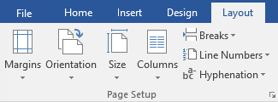Setting the Page Orientation
1. On the Page Layout tab click the Orientation
button and then select Portrait or Landscape.

Modifying the Margin Settings
1. On the Page Layout tab, click the Margins button, then select one of the options, or choose Custom Margins.

Setting the Paper Size
1. On the Page Layout tab, select the Size button, then select the desired paper size, or choose More Paper Sizes.
Page Breaks
There will often be times when you want a section of text to start at the top of the page. In Word, the command to force text onto a new page is called a page break.

To Create a Page Break
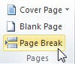1. From the Insert tab, click the Page Break button.
OR
Use the keyboard command Ctrl + Enter.
OR
From the Page Layout tab, click the Breaks button and select Page.
Bullets and Numbering
Bullets and numbering are used to emphasize points in your document or to format brief lists. Lists can be created as you type, or list formatting can be applied to already existing text.

Creating a List from Existing Text
- 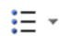Select the text that is to be formatted as a list.
- In the Home tab, click the Bullets or Numbering button.

Creating a List as You Type
- In the Home tab, click the Bullets or Numbering button.
OR
For a numbered list, type in the number 1. and press the Tab key or space bar.
- Type in the first item on the list.
- Press the Enter key on the keyboard. The next number or bullet is added.
- To end the list, press the Enter key again.

Stopping Word from Creating a List from a Numbered Item
- Type in your number and press Tab. Word realigns your line.
- Press the Undo button.
OR
Use the keyboard command Ctrl + Z. Word will undo the automatic formatting.

Indents
An indent is the distance between the text and the margins. There are four types of indents: first line indents, hanging indents, left indents, and right indents.
First Line Indent
When you press the tab key to indent your first paragraph, Word automatically indents subsequent paragraphs.
Creating a First Line Indent from the Ribbon
- In the Paragraph section of the Home tab, click the arrow in the lower right corner.
- The Paragraph dialog box opens. In the Indentation section, under Special, select First line.
- Click OK.
Left and Right Indents
Left and right indents place distance between the text and the left and/or right margins.
Creating an Indent from the Ribbon
- In the Paragraph section of the Home tab, click the arrow in the lower right corner.
- In the Indenting section, in the spin box beside Left or Right select or type in the desired distance.
- Click OK.

Using the Indent Icon
- Select the text to be indented.
- In the Paragraph section of the Home tab, click the Increase / Decrease Indent
button.
Hanging Indents
A hanging indent keeps the first line of text flush with the margin and moves the remaining lines of text to the right.

Creating a Hanging Indent with the Ribbon
- In the Paragraph section of the Home tab, click the arrow in the lower right corner.
- In the Paragraph dialog box, in the Indentation section, select Hanging.
- Click OK.

Tabs
Tabs are used to offset text. Pressing the tab key automatically moves the cursor to the next 1/2 inch measurement in the document. Word provides multiple tab styles: left, center, right, and decimal.
Tabs can also have options, such as dot leaders, which are simply dots that appear between the tab and the text.

Left Tab | Center Tab | Decimal.Tab | Right Tab
Malcolm Reynolds | male | 72.5 | Captain
Zoe Washburn | female | 71.75 | First Mate
Jayne Cobb | male | 75.75 | Second Mate
Hoban Washburn | male | 72 | Pilot
Kaylee Frye | female | 68.045 | Mechanic

Setting Tabs
- 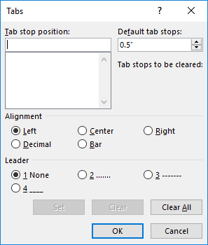In the Paragraph section of the Home tab, click the arrow in the lower right corner.
- In the lower left corner of the Paragraph dialog box, click the Tabs button.
- In the Tabs dialog box, type in the distance from the left margin where the first tab should be placed.
- Under Alignment, select a tab style.
- Under Leader, select a leader style.
- Click Set, then click OK.

Deleting Tabs
- Highlight the text containing the tabs to be deleted.
- Open the Tabs dialog box.
- Select the tab to be deleted and press the clear button.
OR
Press the Clear All button to delete all tabs in the highlighted section.

Styles
Styles are a way of applying a set format to a line of text, and are available on the Home tab.

Applying Styles from the Ribbon
- 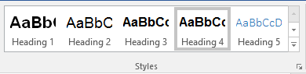Select the text to be formatted.
- In the Styles section of the Home tab, choose one of the visible headings, or click the arrow for more styles.
OR
1. Use the keyboard commands:
Heading 1 Alt + Ctrl + 1
Heading 2 Alt + Ctrl + 2
Heading 3 Alt + Ctrl + 3
Normal Ctrl + Shift +N

Find / Replace
If you are looking for anything beyond a word or phrase, or want to use the replace options, open Advanced Find.
- Click the Find button or use the keyboard command Ctrl +F.
- The Navigation pane opens to the left. Beside the text box click the triangle.
- From the menu select Advanced Find. OR
Use the keyboard command Ctrl + H.
- The Find and Replace dialog box opens. Click the More button to see further options.
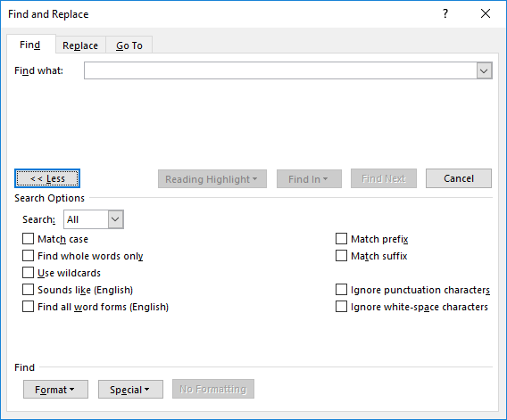

Match case | Looks for text exactly as it is typed into the Find What box, including capitalization.
Find whole words only | Searches for complete words. The option for find whole words only should almost always be selected when using find & replace.
Use wildcards | Allows you to search for parts of words or characters within a word, using the characters ?, *, [], and [-].
Sounds like (English) | Searches for words that sound like the word in the Find what box.
Find all word forms | Searches for all forms of the word, such as bag, bagged, baggie, and bagging.
Match prefix | Match the prefix of the word.
Match suffix | Match the suffix of the word.
Ignore punctuation characters | Ignores punctuation when searching for a word or phrase.
Ignore white space characters | Ignores spaces between words and letters when searching for a word.
Format | Selects based on formatting, such as Bold or Highlighting
Special | Selects special characters such as Tabs or Paragraph breaks

Spell Check
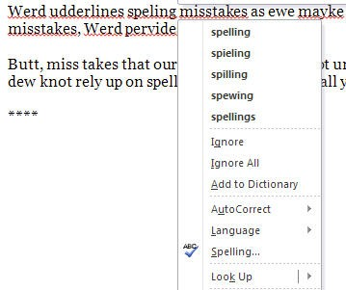Word automatically checks your document for errors as you type, and underlines duplicated and unrecognized words in red. You can then fix these mistakes as you write your document.

Correcting Mistakes as you Type
- Right click on any word underlined in red.
- From the context menu, select the correct spelling, if it is listed.
- If the word is spelled correctly, you can choose Ignore All to ignore the word in the current document, or Add to Dictionary to add the word to your custom dictionary.

Pictures
Pictures are placed into documents to clarify a section of text, to present data in graphical form, to entertain, etc. For instructions on how to add images to your document, please see the Office basics handout.
Formatting Pictures
By default, pictures are inserted “in line with text.” This makes the image part of the sentence, and often makes it difficult to move images in the document. Word allows you to change the layout style so you can place images more precisely on the screen.

In line with text | Images appear in the same line as the text. Text does not wrap around the image. The image may be difficult to move in the document.
Square | Text wraps around the image, the image can be moved in the document with relative ease.
Tight | The same as square, only the text runs close to the edges of the image.
Behind text | Places the image behind the text.
In front of text | Places the image in front of the text.
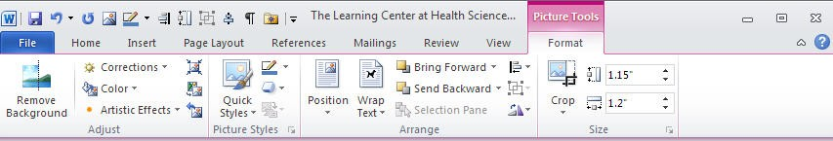

Changing Image Layout
- Click once on the image to select it. Select the Picture Tools Format tab.
OR
Double click on an image to bring up the Picture Tools Format tab in the ribbon.
- In the Arrange portion of the Format Pictures Tools tab, click the triangle beside Wrap Text and select the desired text wrapping. Square is typically the best choice if you need to move your image.

Tables
A table is an element composed of individual cells that have been arranged into rows and columns. Rows are the horizontal elements of a table, columns are the vertical elements of a table. Tables are most frequently used to present data in an easy to read manner.

To Create a Table
- Select the Insert tab.
- 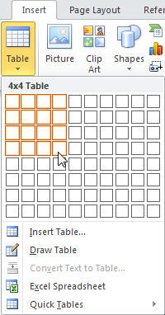Click the Table button. A drop down menu appears. Highlight the desired number of rows and columns for your table and then click.

To Move in a Table
- Press the Tab key to move to the right.
- Press Shift + Tab to move to the left.
- Press the arrow keys to move in the indicated direction.
Table Rows

To Select a Row
1. Place the cursor to the left of the table. When the cursor changes to a right pointing arrow, click to select the row to the right.
OR
Click and drag to select all the cells in a single row.

Table Columns

To Select a Column
1. Place your cursor directly over the column until the cursor changes to a small, black arrow. Click the left mouse button.
OR
Click and drag to select every cell in the column.

Table Tools Design Tab
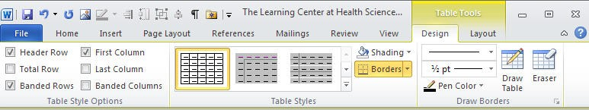

Table Tools Layout Tab
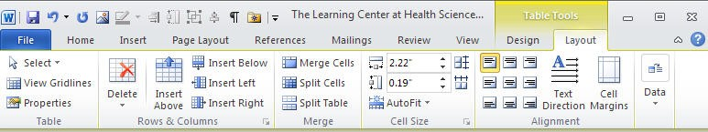

To Add Rows/Columns to a Table
1. When you have reached the last cell of the table, press the Tab key to create a new row.
OR
- Right click in the row above or below which you want the new row to appear or select the column to the left or right of where the new column should appear. To insert multiples, highlight a number equal to the number to be inserted.
- From the drop down menu select Insert, then Insert Rows Above / Below or Insert Columns to the Right / Left.
OR
- Highlight the row above or below/column to the left or right of which you want the new row to appear. To insert multiple rows, highlight a number of row equal to the number of rows to be inserted.
- In the ribbon select the Table Tools Layout tab.
- In the Rows & Columns section, select the desired option.

To Delete Rows/Columns from a Table
- Select the rows/columns to be deleted.
- 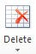Right click and choose Delete Row(s)/Column(s). OR
- Select the rows/columns to be deleted.
- In the ribbon choose the Table Tools Layout tab.
- Click the Delete button.
- Select the desired option from the drop down menu.

Row Height and Column Width

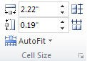To Set Row and Column Size
- Select the row or column (or entire table) to be formatted.
- In the ribbon select the Table Tools Layout tab.
- In the Cell Size section, change the height and width to meet your needs, or press the AutoFit button.

AutoFit
AutoFit automatically resizes the table to your specifications. There are three choices for AutoFit.

To Use AutoFit
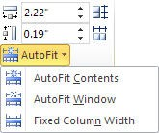
- Select the row or column (or entire table) to be formatted.
- In the ribbon select the Table Tools Layout tab.
- Press the AutoFit button.
- From the drop down menu select the desired option.
OR
- Select the row, column, or entire table to be formatted.
- Right click and choose AutoFit.
- From the drop down menu select the desired option.

Sort
Word allows you to sort both text and numbers.

To Sort a List
- Select the terms to be sorted.
- Select the Home tab.
- Click the Sort button.
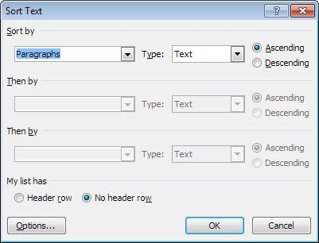
- In the Sort Text dialog box, choose whether the data should be sorted as text or numbers, and then select Ascending or Descending.
- Click OK.

Columns
Newspaper style columns allow text to flow from the bottom of one column to the top of the next.

Columns are useful when creating newsletters and brochures, or when working with long lists of short items in a document.

For example, the following text is divided into three columns:

Word I Word II Mail Merge
Excel I Excel II Pivot Tables
PowerPoint I PowerPoint II

Columns can be created for an entire document, or for selected portions of a document. Different sections of your document can have different numbers of columns. If only a portion of the document will be formatted with multiple columns, it may be easier to add the text that is to be placed in columns and then select and format that text.

To Create Columns from the Ribbon
- Select the text that is to be formatted into columns, or place the cursor where the columns will begin.
- Select the Page Layout tab.
- In the Page Setup section, click the Columns button and select the desired number of columns.

Column Breaks
Column breaks allow you to force text to appear at the top of the next column. This allows you to add text and images to later columns, without filling previous columns.

To Create a Column Break
- Place the cursor where the new column should begin.
- 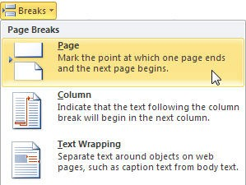Select the Page Layout tab.
- In the Page Layout section, click the Breaks button, then from the drop down menu choose Column.

Envelopes
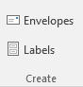Word allows you to print the delivery address and return address on an envelope. If you want to print multiple envelopes at one time, please see the Mail Merge documentation.

Creating and Print an Envelope
- Select the Mailings tab.
- In the Create section click the Envelopes button.
- 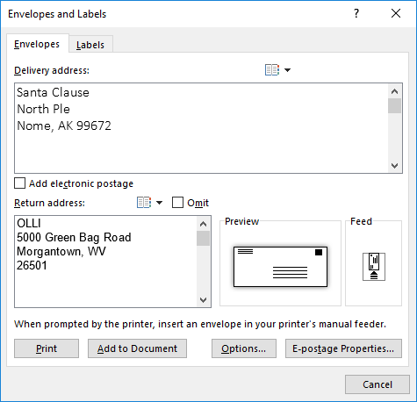In the Envelopes and Labels dialog box, type in the
Delivery address and the Return address.
- To print a single envelope, press Print. OR
To create a new document that can be saved and printed at a later time, press Add to Document.

Return Address Labels
Word allows you to create a full sheet of return address labels. To create labels for multiple addresses, please see the Mail Merge handout.

Creating Return Address Labels
- Select the Mailings tab.
- In the Create section click the Labels button.
- 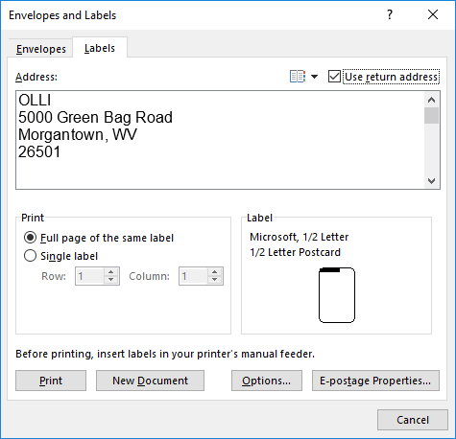In the Envelopes and Labels dialog box, type in the return address.
- To change the label type, click once on the label. Then select a new label type from the list.
- To print the labels immediately, press Print. OR
To save the document to print later, click New Document.

Updating Date and Time
Word provides an option that allows you to automatically update the date and/or time every time you save a document.

Adding a Date/Time Stamp
- 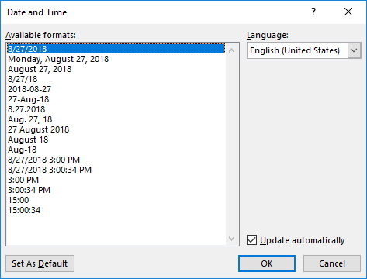Select the Insert tab.
- In the Text section, click the Insert Date & Time button.
- In the Date and Time dialog box, select the desired format.
- If desired, place a check beside Update Automatically in the lower right corner.
- Click OK.

Page Numbering
In Word, page numbering lives in the header/footer of the document.

To Create Page Numbering
- 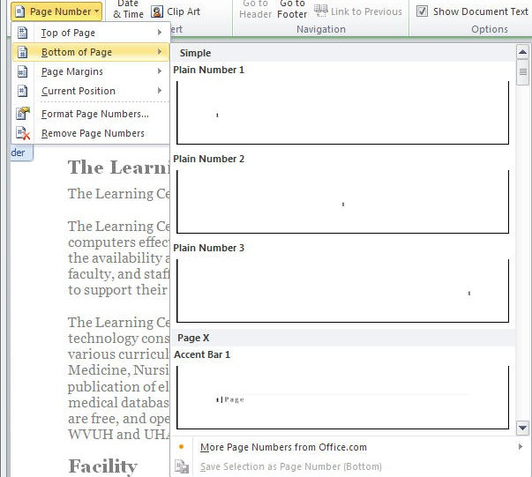In the Header and Footer tab OR in the Insert tab, click the Page Number button.
- Select a location for the page number.
- Choose a format for the page number.

- The page number appears in the footer.
- To return to the document, press the Close Header and Footer button on the ribbon.

Default Settings
Microsoft has default settings for some options that may be different from your default settings. For instance, you may prefer to use a different font, or different margin settings. In Word, these things can be changed from the Page Setup dialog box and the Font dialog box.

Changing a Default Setting
- Open a new document.
- Change the settings as desired.
- Open the Font or Page Setup dialog box.
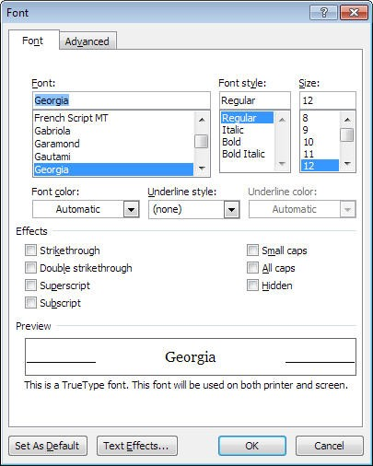
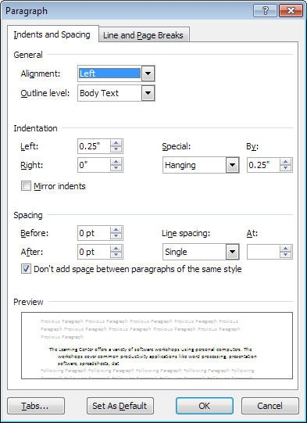
- Click the Default button in the lower right corner.

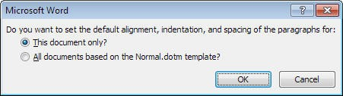
- A dialog box appears asking whether you want to change your default settings. Click OK.

How-To Table of Contents

Selecting Characters 3
Selecting Whole Words 3
Selecting Whole Paragraphs 3
Selecting a Whole Word 3
Selecting a Sentence 3
Selecting a Line 3
Selecting a Paragraph 3
Selecting the Entire Document 3
Deselecting Text 3
Changing Line Spacing 4
Changing Paragraph Alignment 4
Setting the Page Orientation 5
Modifying the Margin Settings 5
Setting the Paper Size 5
To Create a Page Break 5
Creating a List from Existing Text 5
Creating a List as You Type 5
Stopping Word from Creating a List from a Numbered Item 5
Creating a First Line Indent from the Ribbon . 6 Creating an Indent from the Ribbon 6
Using the Indent Icon 6
Creating a Hanging Indent with the Ribbon 6
Setting Tabs 7
Deleting Tabs 7
Applying Styles from the Ribbon 7
Correcting Mistakes as you Type 9
Changing Image Layout 9
To Create a Table 10
To Move in a Table 10
To Select a Row 10
To Select a Column 10
Table Tools Design Tab 11
Table Tools Layout Tab 11
To Add Rows/Columns to a Table 11
To Delete Rows/Columns from a Table 11
To Set Row and Column Size 12
To Use AutoFit 12
To Sort a List 12
To Create Columns from the Ribbon 13
To Create a Column Break 13
Creating and Print an Envelope 14
Creating Return Address Labels 14
Adding a Date/Time Stamp 15
To Create Page Numbering 15
Changing a Default Setting 16

Word Quick Reference

Command | Tab Location | Other Location | Keyboard | Reference
Align Image | Picture Tools Format > Arrange
Align Text Center | Home > Paragraph | Mini Toolbar | Ctrl + E
Align Text Left | Home > Paragraph |  | Ctrl + L
Align Text Right | Home > Paragraph |  | Ctrl + R
Arrange Windows | View > Arrange All
Arrows | Insert > Shapes > Block Arrows |  |  | 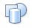
AutoCorrect Options | File > Options > Proofing
AutoFit | Table Tools > Layout > Cell Size | Right click
Backstage View | File |  | Alt + F
Bold | Home > Font | Mini Toolbar | Ctrl + B
Bookmarks | Insert > Links
Bullets | Home > Paragraph | Mini Toolbar | Ctrl+Shift+L
Caption | References > Caption |  |  | 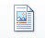
Change Case | Home > Font |  | Shift + F3
Clear Formatting |  |  | Ctrl + Spacebar
Close | File > Exit button | Title bar | Ctrl + W
Column Break | Page Layout > Breaks button > Column |  | Ctrl + Shift + Enter | 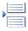
Columns | Page Layout > Page Setup
Compress Pictures | Picture Tools Format > Adjust
Copy | Home > Clipboard | Right click | Ctrl + C
Crop Image | Picture Tools Format > Size |  |  | 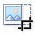
Cross Reference | References > Captions  OR  Insert > Links

Command | Tab Location | Other Location | Keyboard | Reference
Custom  Dictionary | File > Options > Proofing  > Custom Dictionaries
Cut | Home > Clipboard | Right click | Ctrl + X
Date | Insert > Insert Date & Time
Document Views | View > Document Views | Status Bar
Envelopes | Mailings > Create
Find | Home > Editing |  | Ctrl + F
Font | Home > Font | Mini Toolbar | Ctrl + D
Footnote | References > Footnote |  | Alt+Ctrl+F | 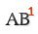
Form Controls | Developer * > Controls |  |  | 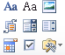
Format Object | Drawing Tools Format tab | Right click
Format Painter | Home > Clipboard | Mini Toolbar | Ctrl+Shift+C Ctrl+Shift+V
Headers  / Footers | Insert > Header & Footer |  |  | 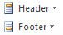
Headings | Home > Styles | Right click | Alt + Ctrl + 1 Alt + Ctrl + 2 Alt + Ctrl + 3 Ctrl+Shift+N
Hide the Ribbon | Double click on any tab |  | Ctrl + F1
Hyperlink | Insert > Links | Right click | Ctrl + K
Image Border | Picture Tools Format > Picture Styles
Images | Insert > Illustrations |  |  | 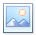
Import Chart | Insert > Text > Insert Object button
Indent | Home > Paragraph | Mini Toolbar | Ctrl + M
Insert Caption | References > Caption |  |  | 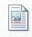
Italic | Home > Font | Mini Toolbar | Ctrl + I
Labels | Mailings > Create |  |  | 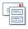

Command | Tab Location | Other Location | Keyboard | Reference
Landscape /  Portrait | Page Layout > Page Setup
Layout View | View > Document Views | Status Bar
Line Spacing | Home > Paragraph |  | Ctrl + 1  Ctrl + 2
Macros | View > Macros |  |  | 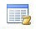
Mail Merge | Mailings > Start Mail Merge |  |  | 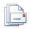
Margins | Page Layout > Page Setup
Merge Cells | Table Tools Layout > Merge | Right click
New Document | File > New tab |  | Ctrl + N
Non-Keyboard Characters | Insert > Symbols
Numbering | Home > Paragraph | Right click
Open | File > Open |  | Ctrl + Open
Open Recent File | File > Recent tab | Quick Access Toolbar
Orientation | Page Layout > Page Setup
Page Break | Page Layout > Breaks  OR  Insert > Page Break |  | Ctrl + Enter
Page Numbering | Insert > Header & Footer
Paper Size | Page Layout > Page Setup
Paragraph Formatting | Home > Paragraph | Right click
Paste | Home > Clipboard | Right click | Ctrl + V
Paste Special | Home > Clipboard | Right click | Ctrl+Alt+V | 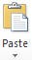
Picture | Insert > Illustrations
Picture Border | Picture Tools Format > Picture Styles
Print | File > Print |  | Ctrl + P | 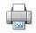

Command | Tab Location | Other Location | Keyboard | Reference
Program  Options | File > Options button
Recent Files | File > Recent tab | Quick Access toolbar
Redo |  | Quick Access Toolbar | Ctrl + Y
Replace | Home > Editing |  | Ctrl + H
Restrict Editing | Developer * > Protect |  |  | 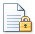
Ruler | View > Show | Scroll Bar > View Ruler Button
Save | File > Save or Save As | Quick Access Toolbar | Ctrl + S
Save As | File > Save As button |  | F12
Screen Clipping | Insert > Illustrations |  |  | 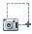
Screenshots | Insert > Illustrations
Section Break | Page Layout > Page Setup  > Breaks button
Select All | Home > Editing |  | Ctrl + A
Shapes | Insert > Illustrations
Show / Hide Codes | Home > Paragraph |  | Ctrl+Shift+8 (Ctrl + *)
Sort | Home > Paragraph
Spell Check | Review > Proofing | Right click | F7 | 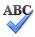
Spell Check Options | File > Options > Proofing
Styles | Home > Styles | Right click | Alt + Ctrl + 1 Alt + Ctrl + 2 Alt + Ctrl + 3 Ctrl+Shift+N
Subscript | Home > Font |  | Ctrl + =
Superscript | Home > Font |  | Ctrl + Shift + =
Switch Windows | View > Window | Windows Taskbar | Alt + Tab | 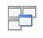
Symbols | Insert > Symbols

Command | Tab Location | Other Location | Keyboard | Reference
Table | Insert > Tables |  |  | 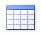
Table Border | Home > Paragraph  OR  Table Tools Design tab > Table styles
Table of Contents | References > Table of Contents
Table: Add Row / Column | Table Tools Layout > Rows & Columns
Table: Deleting | Table Tools Layout > Rows & Column |  |  | 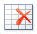
Tabs | Home > Paragraph > Paragraph dialog box > Tabs
Text Box | Insert > Text |  |  | 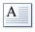
Text Size | Home > Font | Mini Toolbar | Ctrl+Shift+P
Text Wrap | Picture Tools Format > Arrange |  |  | 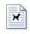
Thesaurus | Review > Proofing | Right click
Time | Insert > Insert Date & Time
Track Changes | Review > Tracking |  | Ctrl+Shift+E | 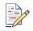
Underline | Home > Font | Mini Toolbar | Ctrl + U
Undo |  | Quick Access Toolbar | Ctrl + Z
Update Selected Fields |  | Right click | F9
Update Table of Contents | References > Table of Contents | Right click
View | View > Document Views | Status Bar
View Table Gridlines | Table Tools Layout > Table
View Two Pages | View > Zoom
Word Art | Insert > Text
Word Count | Review > Proofing |  | Ctrl+Shift+G | 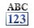

Command | Tab Location | Other Location | Keyboard | Reference
Zoom | View > Zoom | Status Bar

Please Support OLLI@WVU!
Osher Lifelong Learning Institute Mountaineer Mall Unit C-17
PO Box 9123
Morgantown, WV 26506-9123 Phone Numbers:

Office: (304) 293-1793
Email Address: olli@hsc.wvu.edu http://www.olliatwvu.org

